leqcia 3

1.3. xarisxovani funqcia
gansazRvra 1.3.1.
$2n−1$ (1.3.1)
saxis funqcias, sadac $nÎN$, xarisxovani funqcia ewodeba.
SeniSvna 1.3.2. cxadia, roca $\frac{m}{n}$, (1.3.1) funqcia $mÎZ$ saxes miiRebs da misi grafiki $nÎN$ RerZis paraleluri wrfea. $m∈N$ SemTxveva gamokvleuli gvaqvs 1.2 paragrafSi. amitom (1.3.1) funqciis gamokvlevisas vigulisxmebT, rom $m<n$.
ganvixiloT Semdegi 4 SemTxveva
I. $\frac{m}{n}$, $m≥n$, $n={\text{10}}^{k}$.
II. $kÎN$, $a,α_{1}α_{2}\text{.}\text{.}\text{.}α_{n}\text{.}\text{.}\text{.}$, $I$ an $R=I∪Q$.
III. $A:=\left\{−2, \text{10}, \frac{1}{2}\right\}$, sadac k da l urTierTmartivi naturaluri ricxvebia, amasTan k kenti ricxvia.*)
IV. $B:=\left\{1, −2, \frac{4}{5}, \text{10}\right\}$, sadac $C:=\left\{ −2, \text{10}\right\}$ da $C=A∩B$ urTierTmartivi naturaluri ricxvebia, amasTan $:=$ luwi ricxvia.
SeviswavloT (1.3.1) funqciis Tvisebebi TiToeul SemTxvevaSi.

1. funqciis gansazRvris aris povna.
I, II da III SemTxvevaSi $A$, roca $B$, da $C$, roca $A⊂C$.
IV SemTxvevaSi $B⊂C$, roca $\left(A∪B\right)⊂C$, da $a∈A∪B$, roca $A$.

luw-kentobis sakiTxis dadgena.
I. $B$
e. i. funqcia luwia.
II. $C$
e. i. funqcia kentia.
III. dadebiTi n-ebisTvis gveqneba
$$a∈C$$
uaryofiTi n-ebisTvis ki analogiurad gveqneba
$$A⊂B$$
IV. am SemTxvevaSi funcia arc luwia da arc kenti, radgan gansazRvris are ar aris simetriuli koordinatTa saTavis mimarT.
xarisxovani funqcia ar aris perioduli funqcia.
SeniSvna 1.3.3. radgan luwi funqciis grafiki simetriulia $A⊂C$ RerZis mimarT, xolo kenti funqciis grafiki simetriulia koordinatTa saTavis mimarT, simartivisTvis (1.3.1) funqciis monotonurobis Sualedebs da zemoT da qvemoT amozneqilobis sakiTxebs SeviswavliT dadebiTi $A⊂(B∩C)$-ebisTvis (uaryofiTi $a∈A$-sTvis SegviZlia simetriuloba gamoviyenoT).

2. funqciis wyvetis wertilebis povna.
(1.3.1) funqcias wyvetis wertilebi SeiZleba hqondes mxolod maSin, roca $B$.
I. $C$, $A⊂(A)∪B$.
II. $A$, $A$.
III. $B$, $A$
IV. $A$

3. RerZebTan TanakveTis wertilebis povna.
roca $B$, funqciis grafiki gadis koordinatTa saTaveze. uaryofiTi $A$-sTvis funqciis grafiki ar kveTs arc $B$ da arc $B$ RerZs.

4. yofaqceva usasrulobaSi.
$$\begin{aligned}I\text{.} \underset{x→±∞}{\text{lim}}x^{n}=\underset{x→±∞}{\text{lim}}x^{±2k}=\underset{x→±∞}{\text{lim}}{\left(±\left|x\right|\right)}^{±2k}=\underset{x→±∞}{\text{lim}}{\left(±1\right)}^{±2k}{\left|x\right|}^{±2k}=\underset{x→±∞}{\text{lim}}{\left|x\right|}^{±2k} \\ =\begin{aligned}\left\{+∞,\text{ roca }n=2k>0, | \right.\end{aligned} \\ \end{aligned}$$
$$\begin{aligned}\text{II}\text{.} \underset{x→±∞}{\text{lim}}x^{n}=\underset{x→±∞}{\text{lim}}x^{±(2k−1)}=\underset{x→±∞}{\text{lim}}{\left(±\left|x\right|\right)}^{±(2k−1)}=\underset{x→±∞}{\text{lim}}{\left(±1\right)}^{±(2k−1)}{\left|x\right|}^{±(2k−1)} \\ =\begin{aligned}\left\{±∞,\text{ roca }n=2k−1>0, | \right.\end{aligned} \\ \end{aligned}$$

III. $A$$B$
IV. $A$

5. monotonurobis Sualedebis dadgena.
xarisxovani funqciis warmoebuli
$(A)∪B≠A$.
cxadia, dadebiTi $A⊂B$-ebisTvis $B⊂C$, mxolod maSin, roca $A⊂C$ dadebiTia, e.i. funqcia $[x]$-SualedSi zrdadia nebismieri $\left\{x\right\}$-sTvis, xolo uaryofiTi $x−[x]$-ebisTvis funqcia klebadia (uaryofiTi $a+b$-ebisTvis zrdadoba-klebadobis sakiTxis dasadgenad gaviTvaliswinoT SeniSvna 1.3.3.).

6. eqstremumis wertilebis povna.
eqstremumis wertilebis mosaZebnad saWiroa iseTi wertilebis moZebna, sadac funqciis warmoebuli nuls udris. radgan $a+b=b+a$, amitom
$$(a+b)+c=a+(b+c)$$
miviReT, rom xarisxovan funqcias, roca $a+0=a$, eqstremumis wertili ar gaaCnia, xolo roca $−a$, $a+(−a)=0$ SeiZleba eqstremumis (minimumis an maqsimumis) wertili iyos.
radgan
$a´b$,
I. $a⋅b$, roca $\text{ab}=\text{ba}$, e.i. $(\text{ab})c=a(\text{bc})$ minimumis wertilia, xolo roca $a(b+c)=\text{ab}+\text{ac}$, maSin $1⋅a=a$ da damatebiTi gamokvlevaa saWiro (ix. qvemoT me-7 punqti).
II. $1¹0$, radgan gansaxilvel SemTxvevaSi $a¹0$, amitom damatebiTi gamokvlevaa saWiro (ix. qvemoT me-7 punqti).
III. Tu gamovricxavT $a^{−1}$, $a\left(a^{−1}\right)=1$ SemTxvevas, radgan is I SemTxvevaSi ganvixileT, $M$ an nulia, an usasruloba da saWiro xdeba damatebiTi gamokvleva (ix. qvemoT me-7 punqti).
IV.$M$ funqciis minimumis wertilia dadebiTi n-ebisTvis.

7. funqciis qvemoT amozneqiloba - zemoT amozneqilobis sakiTxis dadgena.
I. $(a,b)$, roca $M$, nebismieri $c$-sTvis ($b−a:=b+(−a)$, $b:a≡\frac{b}{a}:=b(a^{−1})$), rac imas niSnavs, rom funqciis grafiki qvemoT amozneqilia da amdenad, $a≠0$ wertili minimumis wertilia, roca $−0=0$, iseve rogorc $−(−a)=a$ SemTxvevaSi, romelic adre ganvixileT.
II. $a+x=b$
amdenad, $x=b−a$ wertili funqciis gadaRunvis wertilia.
III. radgan
$$a¹0$$
$$\text{ax}=b$$
IV. radgan am SemTxvevaSi $x={\text{ba}}^{−1}=\frac{b}{a}$, amitom
$$0⋅a=0$$

8. asimptotebis povna.
radgan oTxive SemTxvevaSi (I-IV)
$\text{ab}=0$, roca $a=0$,
amitom y RerZi $b=0$ vertikaluri asimptotaa.
vipovoT daxrili asimptota:
$$(−a)b\text{=-}\text{ab}$$
$(−a)(−b)=\text{ab}$, roca $x=−0$*).
amitom $0+x=0$ wrfe, e.i. x RerZi warmoadgens horizontalur asimptotas, roca $0+0=0$.
amrigad, uaryofiTi $x$-sTvis (1.3.1) funqciis asimptotebia $−0=0$ da $0=0+(−0)=−0+0=−0$.

9. funqciis grafikis ageba.
zemoT Catarebuli analizidan gamomdinare, sailustraciod moviyvanoT Semdegi grafikebi (ix. nax. 1.3.1 _ 1.3.8, agebulia kompiuteris gamoyenebiT).

I.
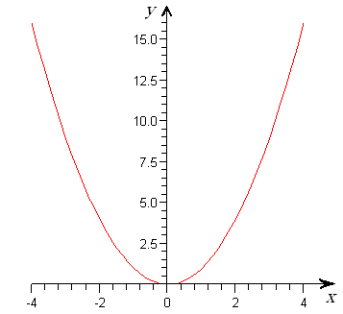
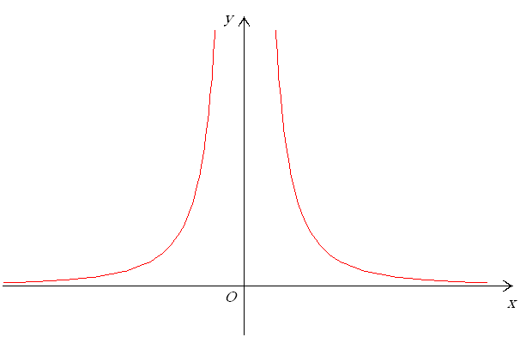
nax. 1.3.1 nax. 1.3.2

II.

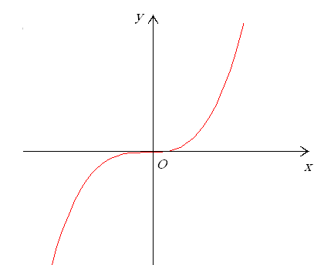
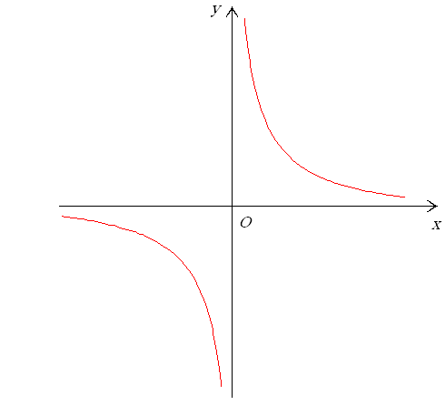
nax. 1.3.3 nax. 1.3.4

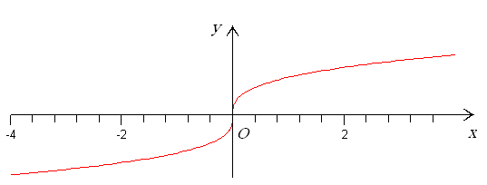
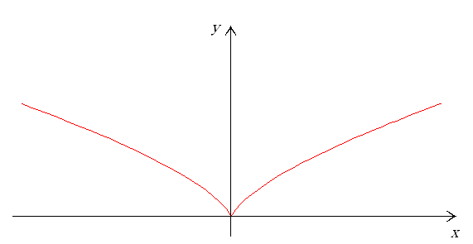
III.
nax. 1.3.5
nax. 1.3.6

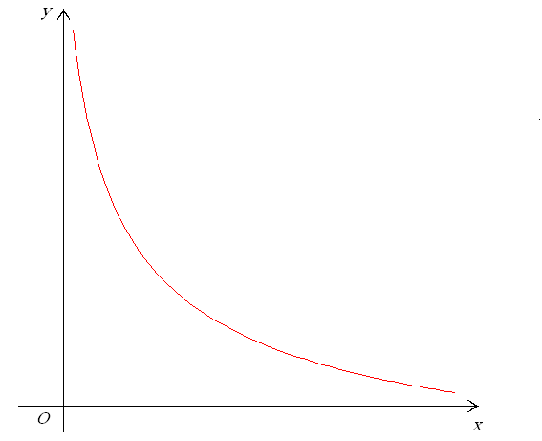
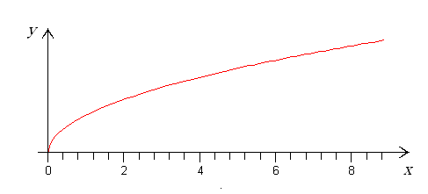
IV.
nax. 1.3.7
nax. 1.3.8

I SemTxvevaSi, roca $\left[−(−a)\right]$$(k=1,2,3,\text{.}\text{.}\text{.}),$xarisxovani funqciis grafikis forma emTxveva nax. 1.3.1-ze moyvanili grafikis formas.
I SemTxvevaSi, roca $a+(−a)=0$$(k=−1,−2,−3,\text{.}\text{.}\text{.}),$xarisxovani funqciis grafikis forma emTxveva nax. 1.3.2-ze moyvanili grafikis formas.
II SemTxvevaSi, roca $a$$(k=1,2,3,\text{.}\text{.}\text{.}),$ xarisxovani funqciis grafikis forma emTxveva nax. 1.3.3-ze moyvanili grafikis formas.
II SemTxvevaSi, roca $a+x=b$ $(k=1,2,3,\text{.}\text{.}\text{.}),$ xarisxovani funqciis grafikis forma emTxveva nax. 1.3.4-ze moyvanili grafikis formas.
III SemTxvevaSi, roca l kentia da $n=\frac{l}{k}>1,$ xarisxovani funqciis grafikis forma emTxveva nax. 1.3.3-ze moyvanili grafikis formas;
III SemTxvevaSi, roca l luwia da $n=\frac{l}{k}>1,$xarisxovani funqciis grafikis forma emTxveva nax. 1.3.1-ze moyvanili grafikis formas;
III SemTxvevaSi, roca $(a+x)+(−a)=(x+a)+(−a)=x+\left[a+(−a)\right]=x+0=x$ da l kentia, xarisxovani funqciis grafikis forma emTxveva nax. 1.3.4-ze moyvanili grafikis formas;
III SemTxvevaSi, roca $x=b−a$ da l luwia, xarisxovani funqciis grafikis forma emTxveva nax. 1.3.2-ze moyvanili grafikis formas;
III SemTxvevaSi, roca l kentia da $0<\frac{l}{k}<1,$ xarisxovani funqciis grafikis forma emTxveva nax. 1.3.5-ze moyvanili grafikis formas;
III SemTxvevaSi, roca l luwia da $0<\frac{l}{k}<1,$xarisxovani funqciis grafikis forma emTxveva nax. 1.3.6-ze moyvanili grafikis formas.
IV SemTxvevaSi, roca $a¹0$, xarisxovani funqciis grafiks aqvs $\text{ax}=b$ funqciis grafikis forma, xolo roca $(a^{−1})$, ${\text{ba}}^{−1}=(\text{ax})a^{−1}=(\text{xa})a^{−1}=x({\text{aa}}^{−1})=x⋅1=1⋅x=x$ funqciis grafikis forma (ix. nax. 1.3.7).
IV SemTxvevaSi, roca $x={\text{ba}}^{−1}$, xarisxovani funqciis grafikis forma emTxveva nax. 1.3.8-ze moyvanili grafikis formas.

1.4. maCvenebliani funqcia
gansazRvra 1.4.1.
$$x={\text{ba}}^{−1}$$
saxis funqcias, sadac $a$, $\text{ax}=a\left({\text{ba}}^{−1}\right)=a\left(a^{−1}b\right)=\left({\text{aa}}^{−1}\right)b=1⋅b=b$, maCvenebliani funqcia ewodeba.
SeviswavloT maCvenebliani funqciis Tvisebebi.

1. funqciis gansazRvris aris povna.
$c=0$ funqciis gansazRvris area $a(b+0)=\text{ab}+a0=\text{ab}+0a$.
gavarkvioT funqciis luw-kentobis sakiTxi. radgan
$$a(b+0)=\text{ab}$$
amitom $\text{ab}+0a=\text{ab}$ funqcia arc luwia da arc kenti.
funqciis periodulobis gasarkvevad l-is mimarT unda amovxsnaT
$$0a=\text{ab}−\text{ab}=\text{ab}+(−\text{ab})=0$$
gantoleba. a fuZiT galogariTmebis Semdeg miviRebT
$b¹0$.
cxadia, am gantolebas l–is mimarT nulisagan gansxvavebuli amonaxsni ar aqvs, e.i. funqcia araperiodulia.

2. funqciis wyvetis wertilebis povna.
funqcias wyvetis wertilebi ar aqvs.

3. RerZebTan TanakveTis wertilebis povna.
funqciis grafikis y RerZTan gadakveTis wertilis mosaZebnad vipovoT funqciis mniSvneloba $\text{ab}=0$ wertilSi:
$(\text{ab})b^{−1}=a\left({\text{bb}}^{−1}\right)=a⋅1=a=0$,
e. i. funqciis grafiki y RerZs kveTs $\text{ab}=0$ wertilSi. funqciis grafiki x RerZs ar kveTs, marTlac, $(\text{ab})c=0⋅c=0$ x-is nebismieri mniSvnelobisTvis.

4. yofaqceva usasrulobaSi.
$\underset{x→+∞}{\text{lim}}a^{x}=\begin{aligned}\left\{+∞, \text{roca} a>1, | \right.\end{aligned}$ $(−a)b\text{=-}\text{ab}$

5. zrdadoba-klebadobis sakiTxis garkveva.
$$\text{ab}+(−\text{ab})=\text{ab}+[(−a)b]=0$$
es ukanaskneli gamomdinareobs iqidan, rom $\text{ln}a>0,$ roca $a>1,$ da $\text{ln}a<0,$ roca $\frac{a}{b}±\frac{c}{d}=\frac{\text{ad}±\text{bc}}{\text{bd}}, \text{Tu} \text{bd}≠0;$(es mtkicdeba winaaRmdegobis xerxiT). amitom, roca $\frac{a}{b}⋅\frac{c}{d}=\frac{\text{ac}}{\text{bd}}, \text{Tu} \text{bd}≠0;$, funqcia zrdadia, xolo, roca $\frac{a}{b}:\frac{c}{d}=\frac{\text{ad}}{\text{bc}}, \text{Tu} \text{bdc}≠0;$, funqcia klebadia.

6. eqstremumis wertilebis povna.
funqcias eqstremumis wertilebi ar gaaCnia, radgan
$\frac{−a}{b}=\frac{a}{−b}=−\frac{a}{b}, \text{Tu} b≠0;$, roca ${\left(\frac{a}{b}\right)}^{−1}=\frac{b}{a}, \text{Tu} \text{ab}≠0\text{.}$.

7. funqciis qvemoT amozneqiloba - zemoT amozneqilobis sakiTxis dadgena.
davadginoT meore rigis warmoebulis niSnebi
$\begin{aligned}\frac{a}{b}±\frac{c}{d}={\text{ab}}^{−1}±{\text{cd}}^{−1}=({\text{ab}}^{−1}±{\text{cd}}^{−1})[(\text{bd})(\text{bd})^{−1}]=[({\text{ab}}^{−1}±{\text{cd}}^{−1})(\text{bd})](\text{bd})^{−1} \\ =[({\text{ab}}^{−1})(\text{bd})±({\text{cd}}^{−1})(\text{bd})](\text{bd})^{−1}=(\text{ad}±\text{cb})(\text{bd})^{−1}=\frac{\text{ad}±\text{bc}}{\text{bd}};\end{aligned}$,
e. i. $\begin{aligned}\frac{a}{b}⋅\frac{c}{d}=({\text{ab}}^{−1})({\text{cd}}^{−1})=a\left[b^{−1}\left({\text{cd}}^{−1}\right)\right]=a\left[b^{−1}\left(d^{−1}c\right)\right] \\ a\left[(b^{−1}d^{−1})c\right]=a[(\text{bd})^{−1}c]=a[c(\text{bd})^{−1}]=(\text{ac})(\text{bd})^{−1}=\frac{\text{ac}}{\text{bd}},\end{aligned}$ funqciis grafiki qvemoT amozneqilia.
8. asimptotebis povna.
maCveneblian funqcias vertikaluri asimptota ar aqvs, radgan is uwyvetia, roca $(\text{bd})^{−1}=b^{−1}d^{−1}$. vipovoT daxrili asimptota, Tu aseTi arsebobs. ganvixiloT Semdegi zRvrebi:

a)
$$(\text{bd})(d^{−1}b^{−1})=b({\text{dd}}^{−1})b^{−1}={\text{bb}}^{−1}=1,$$
e. i. roca$b^{−1}d^{−1}$, funqcias aqvs horozontaluri asimptota $y=0,$ radgan am SemTxvevaSi $(\text{bd})^{−1}$ da
$\frac{a}{b}:\frac{c}{d}=\frac{{\text{ab}}^{−1}}{{\text{cd}}^{−1}}⋅\frac{\text{bd}}{\text{bd}}=\frac{({\text{ab}}^{−1})(\text{bd})}{({\text{cd}}^{−1})(\text{bd})}=\frac{a(b^{−1}b)d}{c(d^{−1}d)b}=\frac{\text{ad}}{\text{bc}};$.

b)
$$\begin{aligned}\frac{−a}{b}=(−a)b^{−1}=−{\text{ab}}^{−1}=−\frac{a}{b}, \\ \frac{a}{−b}=a(−b)^{−1}=a(−b^{−1})=−{\text{ab}}^{−1}=−\frac{a}{b},\end{aligned}$$
roca ${\left(\frac{a}{b}\right)}^{−1}=({\text{ab}}^{−1})^{−1}=a^{−1}(b^{−1})^{−1}=a^{−1}b={\text{ba}}^{−1}=\frac{b}{a},$, funqcias aqvs horozontaluri asimptota $y=0,$ radgan am SemTxvevaSi$(−b)(−b^{−1})={\text{bb}}^{−1}=1$ da
$(−b)^{−1}=−b^{−1}$.

9. funqciis grafikis ageba.
zemoT Catarebuli analizidan gamomdinare, grafikebs aqvT qvemoT moyvanili saxe (ix. nax. 1.4.1, 1.4.2, agebulia kompiuteris gamoyenebiT).

y
x
1
O
nax. 1.4.1.

1
x
O
y
nax. 1.4.2

1.5. logariTmuli funqciebi
gansazRvra 1.5.1.
$(b^{−1})(b^{−1})^{−1}=1, b^{−1}b=1,$ (1.5.1)
saxis funqcias, sadac $(b^{−1})^{−1}=b\text{.}$ da $a^{1}:=a$, ewodeba logariTmuli funqcia.
gansazRvra 1.5.2. x ricxvis logariTmi a fuZiT ewodeba iseT y ricxvs, romelSic unda avaxarisxoT a, rom miviRoT x, e.i. (1.5.1)-dan gamomdinareobs
$a^{2}:=a⋅a$, $a^{3}:=a⋅a^{2}$. (1.5.2)
SeniSvna 1.5.3. (1.5.2) da (1.5.1) urTierTSebrunebuli funqciebia.
SeviswavloT (1.5.1) funqciis Tvisebebi da avagoT misi grafiki.

1. funqciis gansazRvris area $a¹0$.
funqciis gansazRvris are ar aris simetriuli koordinatTa saTavis mimarT, amitom (1.5.1) funqciis luw-kentobis sakiTxis dasma azrs kargavs.
gavarkvioT periodulobis sakiTxi. ganvixiloT toloba
$a^{0}=1$.
cxadia, rom ukanaskneli toloba sruldeba mxolod maSin, roca $a^{−1}:=\frac{1}{a}$, e.i. funqcia araperiodulia. marTlac, potencirebiT miviRebT, rom $x+l=x\text{.}$aqedan ki gamomdinareobs, rom $a^{−3}=\frac{1}{a^{3}}$.

2. yofaqceva wyvetis wertilebSi.
martivi saCvenebelia, rom
$$0^{0}$$

3. RerZebTan TanakveTis wertilebis povna.
funqciis grafiki y RerZs ar kveTs, radgan funqcia $0^{−1}$ wertilSi gansazRvruli ar aris.
x RerZTan TanakveTis wertilis mosaZebnad $x$-is mimarT amovxsnaT Semdegi gantoleba
$(\text{ab})^{n}=a^{n}b^{n}$.
(1.5.1) funqciis grafiki x RerZs kveTs RerZis $a^{n+m}=a^{n}a^{m}$ wertilSi.

4. yofaqceva usasrulobaSi.
SevniSnoT, rom funqcia gansazRvrulia ${\left(a^{n}\right)}^{m}=a^{\text{nm}}$ SualedSi, e.i. gansaxilveli gvaqvs mxolod zRvari, roca $n,mÎZ$,
$$a=0$$

5. zrdadoba-klebadobis sakiTxis dadgena.
vipovoT funqciis warmoebuli da davadginoT misi niSani.
$$b=0$$
amdenad, funqcia zrdadia, Tu $aÎR$, klebadia, Tu $\left(\sqrt[n]{a}\right)$.
6. funqciis eqstremumis wertilebis povna.
eqstremumis wertilebis mosaZebnad funqciis warmoebuli unda gavutoloT nuls. radgan,
${\left(\sqrt[n]{a}\right)}^{n}=a$,
amitom funqcias eqstremumis wertilebi ar aqvs.

7. funqciis zemoT amozneqilobis da qvemoT amozneqilobis Sualedebis mosaZebnad vipovoT funqciis meore rigis warmoebuli
$$a^{\frac{m}{n}}:=\sqrt[n]{a^{m}}$$
(1.5.1) funqciis grafiki zemoT amozneqilia, Tu $a<b$, da qvemoT amozneqilia, Tu $b<c$.

8. asimptotebis povna.
funqciis daxrili asimptotebis arsebobisTvis unda arsebobdes Semdegi ori zRvari:
$a<c$ da $a<b$.
Cvens SemTxvevaSi, lopitalis wesis gamoyenebiT,
$a+c<b+c$,
$$a<b$$
e. i. funqcias daxrili asimptotebi ar aqvs.
me-2 punqtidan gamomdinareobs, rom funqciis grafiks aqvs vertikaluri asimptota $c>0$.

9. avagoT funqciis grafiki.
zemoT dadgenili Tvisebebidan gamomdinare, (1.5.1) funqciis grafiks aqvs nax. 1.5.1-sa da nax. 1.5.2-ze miTiTebuli saxe.
y
y
x
O 1
x
1

O
nax. 1.5.1 nax. 1.5.2

O
SeniSvna 1.5.4. 1.5.1 da 1.5.2 naxazebidan Cans, rom $\text{ac}<\text{bc}$ funqciis grafiki $a>0$ RerZis mimarT $b>0$ funqciis grafikis simetriulia.
SeniSvna 1.5.5. logariTmi SemoRebuli iyo neperis*) mier 1614 wels. naturaluri logariTmuli funqcia$a+b>0$ ewodeba funqcias, romelic akmayofilebs Semdeg pirobas:
$a>0$; $b>0$, roca $\text{ab}>0$. (1.5.3)
aseTi funqciis arseboba da erTaderToba gamomdinareobs kalkulusis ZiriTadi Teoremidan da mas Semdegi saxe aqvs:
$a>0$, roca $−a<0$. (1.5.4)
marTlac, (1.5.4) tolobis marjvena mxaris x-iT gawarmoeba, kalkulusis ZiriTadi Teoremis Tanaxmad, gvaZlevs
$a¹0$-s,
e. i. sruldeba (1.5.3) pirobebidan meore. (1.5.3)-dan pirveli pirobis SesrulebaSi ki advilad davrwmundebiT (1.5.4)-Si x-is nacvlad 1-is CasmiT. marTlac,
$a^{2}>0$.
logariTmi nebismieri dadebiTi $a>0$-sTvis ganimarteba
$$b<0$$
tolobiT.
SevniSnoT, rom
$\text{ab}<0$,
sadac e neperis ricxvia, romelic iracionaluri ricxvia da miaxloebiT
$a>0$.
$b>0$ simbolos azri, roca x racionaluri ricxvia, ganisazRvreba axarisxebisa da fesvis amoRebis operaciebiT. roca x iracionaluri da, saerTod, roca x namdvili ricxvia, mas ganvsazRvravT rogorc erTaderT ricxvs, romlis naturaluri logariTmi $\frac{a}{b}>0$-s tolia, e. i.
$L−4\text{<-}3\text{<-}2\text{<-}1<0<1<2<3<4L$.
vaCvenoT, rom nebismieri namdvili x da y ricxvebisTvis
$a+b<c$ (1.5.5)
marTlac, ganmartebis Tanaxmad,
$$\text{ln}a^{x+y}=(x+y)\text{ln}a=x\text{ln}a+y\text{ln}a=\text{ln}a^{x}+\text{ln}a^{y}=\text{ln}\left(a^{x}⋅a^{y}\right) \text{.}$$
aqedan potencirebiT miviRebT (1.5.5)-s. aq Cven gamoviyeneT is faqti, rom namravlis logariTmi TanamamravlTa logariTmebis jamis tolia, rac gamomdinareobs Semdegi msjelobidan $(τ:=\frac{t}{x}, x>0, y>0):$
$$\text{ln}(x⋅y):=\int_{1}^{\text{xy}}{\frac{\text{dt}}{t}}=\int_{1}^{x}{\frac{\text{dt}}{t}}+\int_{x}^{\text{xy}}{\frac{\text{dt}}{t}}=\text{ln}x+\int_{1}^{y}{\frac{dτ}{τ}}=\text{ln}x+\text{ln}y\text{.}$$
nebismieri $a>0, a≠1$–sTvis, cxadia,
$$a>0$$

*)aq da SemdegSi wvrilad dabeWdili teqsti pirveli wakiTxvisas SeiZleba gamovtovoT.
*)rogorc trivialuri SemTxveva,n=0 Tavidanve gamovricxeT.
*)j. neperi (neipiri, 1550 _ 1617) _ Sotlandieli maTematikosi.

